**Issue Statement -:** Error While Publishing V4 version service with Eclipse ADT tool for RAP app .

When we are trying to Publish an Odata_V4 version in ECLIPSE tool , we get the error

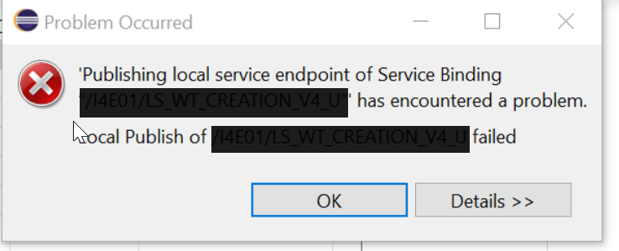

**Information on Issue -:** 3101976 - Publishing OData V4 service is throwing error: Publishing of XXXXXXXXXX in Customizing client not allowed - SAP ONE Support Launchpad

Solution - : Execute Transaction code -> ‘**/n/IWFND/V4_ADMIN’**

* Click on **‘Publish Service Groups’**.

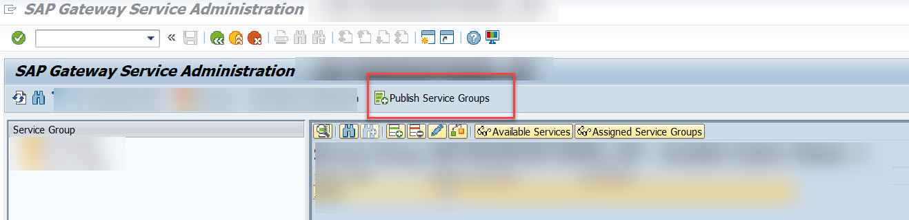

* Select the Service Group and click on **‘Publish Service Groups’**.
* Give System Alias , Service Group ID ( Service Name ) and click on **Get Service Group**s
* Once the service is fetched , select the same and click on **Publish Service group** as below screenshot.

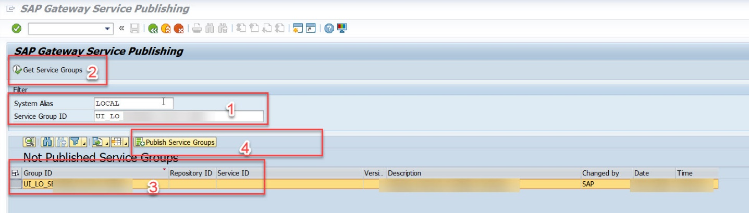

*Publishing the Service Group*

* Click on Continue, you will get a message ‘New service group(s) successfully published’.

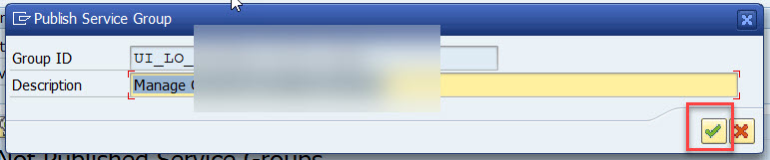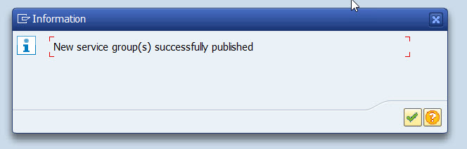

 Once Published , you can go and check in Eclipse tool to see the status of your Odata your oData V4 Service.

